

*Where Theatre and Fun* ***Grow*** *Hand in Hand*

**The Actors Garden, a theatre school brought to you by children’s theatre veteran Gigi Hudson and the area’s finest teaching artists, offers exciting theatrical adventures to your children. Actors Garden takes theatre education very seriously - so seriously that we believe theatre should be taught with a word that is not so serious: Fun!**

**Take a look inside and see how much fun your kids can have!**

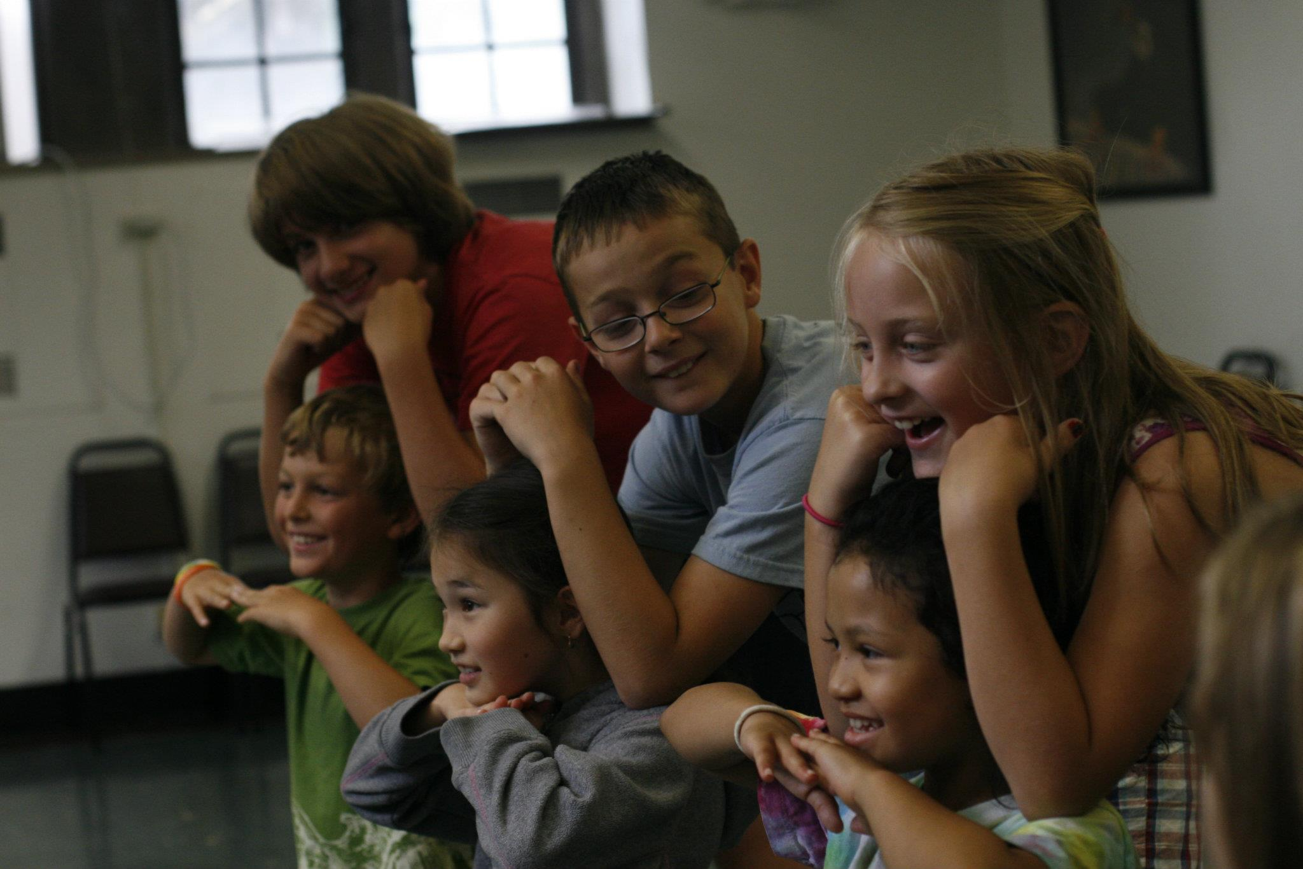

***Actors Garden classes begin the week of SEPTEMBER 17***

***Classes run for ten weeks.***

***All classes meet at Musikgarten of Oak Park /The Actors Garden Studio***

***344 Harrison Street Oak Park, IL 60304 708.369.1055***

**Class Schedule**

**Fall 2012**

**Our Seedling Program** *Ages 3-8*

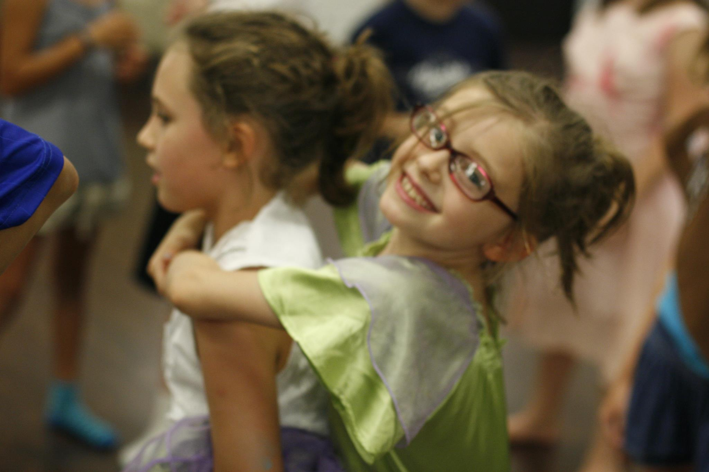

**Tiny Tuneful Tales  
Ages 3-5 Mondays 12:15-1:00pm  
September 17-November 26 No class the week of November 19** **Price 120.00**

A miniature version of our Saturday Tuneful Tales class, Tiny Tuneful Tales will focus on telling and acting out stories through song, creative movement, rhythms and dance - encouraging students to engage their imaginations and sense of dramatic play as they learn about music and theatre. The class will also build skills in listening, story-telling, body awareness, and creative expression.

**Story Fun  
Ages 3-5Wednesdays 12:30-1:15pm September 19-November 28 No class the week of November 19** **Price: 120.00**

With a focus on telling and acting out stories through song, creative movement and theatrical improvisation, this class will encourage students to engage their imaginations and sense of dramatic play as they learn about theatre. This class will also build skills in listening, story-telling, body awareness, and creative expression.

**Theatre FunAges 4-6Fridays 12:45-1:30pmSeptember 21-November 30 No class the week of November 19** **Price: 120.00**

Even the youngest students can get in on the fun! Interactive theater games and story-telling exercises will help students gain confidence on the stage. We will work with props, music and familiar stories to add to the enjoyment.

**Introduction to Theatre  
Ages 5-7 *Fridays* 3:30-4:15pm September 21-November 30 No class the week of November 19**  **Price: 125.00**

Through fun and exciting theatre games, students will learn the basics of creative dramatics while being introduced to the wonderful world of theatre. Students will get a chance to create a new character each week by engaging in the art of story theatre.

**Tuneful Tales  
Ages 5-7 Saturdays 11:45am-12:45pm  
September 22-December 1 No class the week of November 19**  **Price: 125.00**

This class will focus on telling and acting out stories through song, creative movement and theatrical improvisation - encouraging students to engage their imaginations and sense of dramatic play as they learn about music and theatre. Tuneful Tales will also build skills in listening, story-telling, body awareness, and creative expression.

**\*\*\*\*\*\*\*\*\*\***

*"Even if you have a small part, four lines...you always have one moment where you feel great and you shine on stage, and everybody has that chance," 13-year-old Benny Paris*

*"I like the people, and they're practically like family” 12-year-old Quentin Sanders..*

**\*\*\*\*\*\*\*\*\*\***

**Our Garden Program *Ages* *7-15***

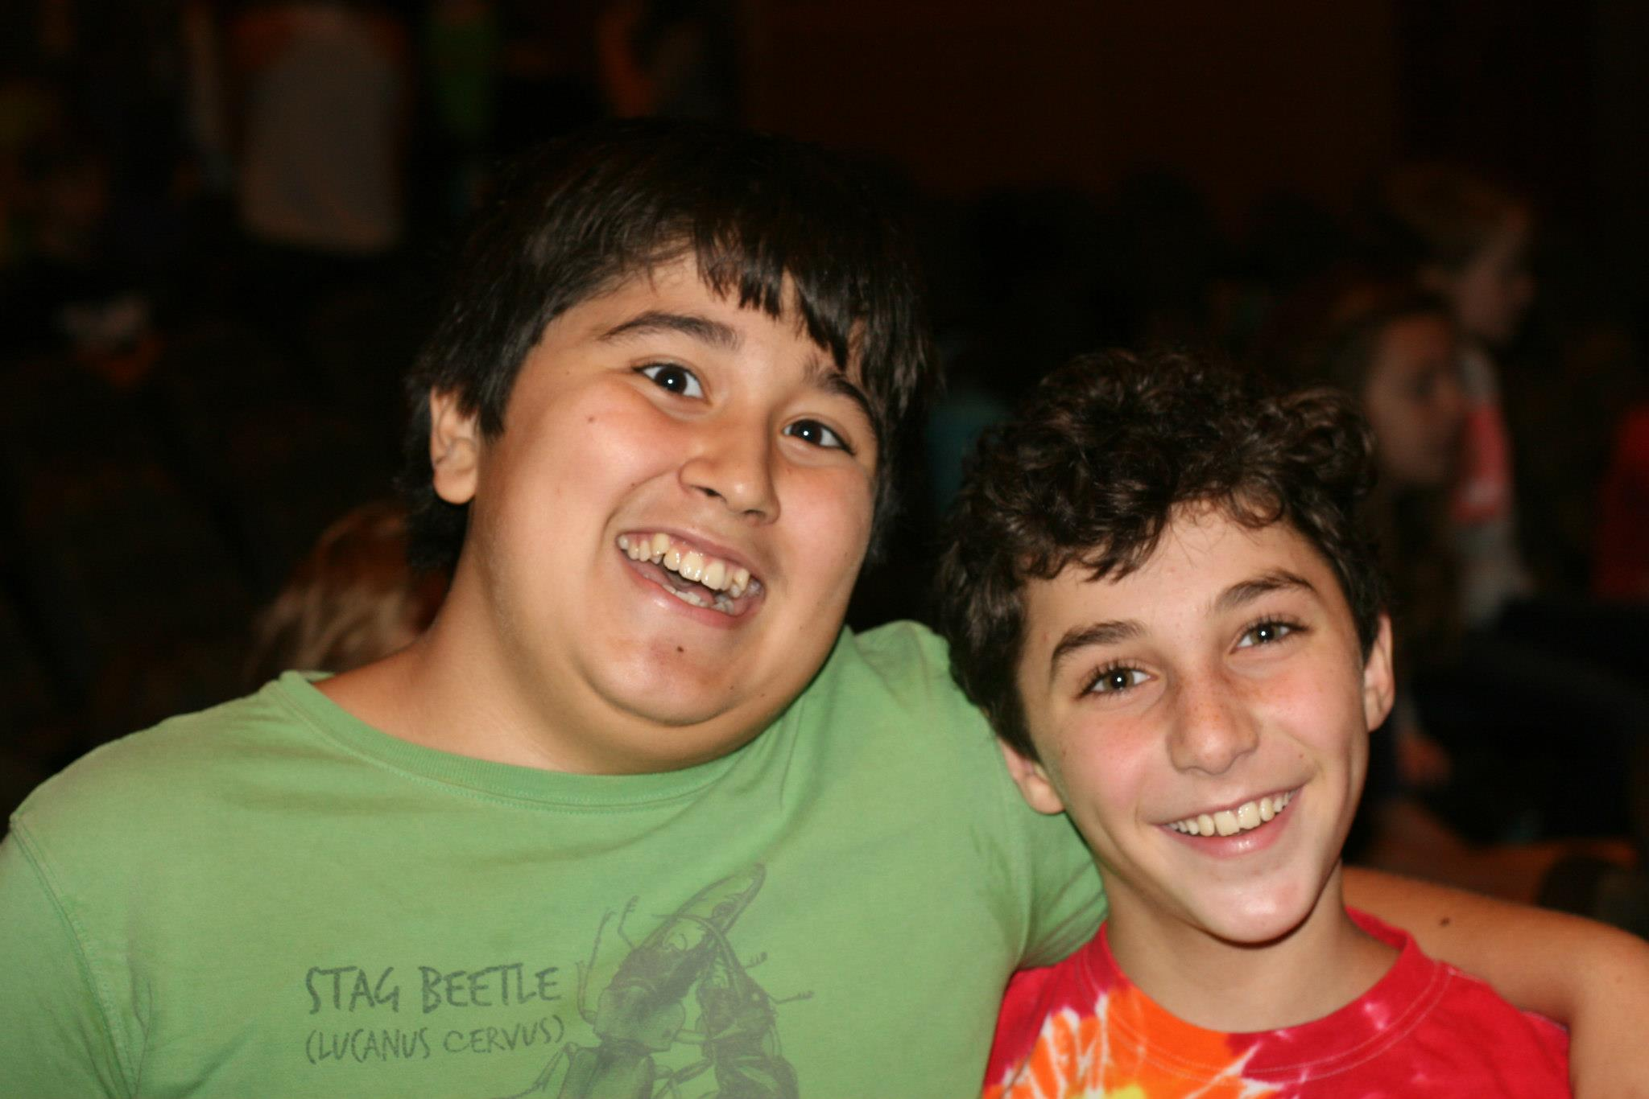

**Adventures in Theatre  
Ages 7-10 Saturdays 1:00-2:00pm  
September 22-December 1 No class the week of November 19**  **Price: 125.00** This class is open to children who are trying theatre for the first time AND those who are seasoned veterans of the stage!  With fun and exciting theatre games, students will learn the basics of creative dramatics and explore all theatre concepts through acting out stories and plays. Students will work with costumes, props and even makeup as we explore the wonderful world of theatre together. A small production will be performed at the end of the ten week class.

***Diving into Dickens* Ages *10-14 Mondays 7:30-9:00pm* September 17-November 26 No class the week of November 19**  ***Price: 160.00***

In this session of Scene Study, students will concentrate on scenes from plays based on the great Charles Dickens. Actors will have ***Great Expectations*** as they find the ***Twist*** in each scene. Students will focus on both acting and learn all about Dickens through fun enrichment activities.

**Improvisation for the Stage *Ages 10-14*Tuesdays 7:30-9:00pm September 17-November 26 No class the week of November 19**  ***Price: 160.00***

Meredith Melville brings years of Improvisation experience to The Actors Garden. This class is for those ready to take on a fun challenge. Improvisation is a great way for actors to learn how to always be in the moment, ready to react and ready to commit to a character. With loads of fun improvisation games, this class is a great way to polish your acting skills.

**The Choreography Project *Ages 10-14 Wednesdays 7:30-9:00pm* September 18-November 27 No classes the week of November 19**  ***Price 160.00***

Bob Fosse, Tommy Tune, Jerome Robbins-these names are synonymous with musical theatre choreography. This class is open to new and returning students. In addition to learning about theatre legends, students will learn how to dance in the style of these gifted artists. Join our own gifted musical theatre artist, Angie Wendt, for a great class that will get you moving.

**Shakespeare Shorts Ages 10-14 Thursdays 7:30-9:00 September 19-November 28 No classes the week of November 19**  ***Price 160.00***

We had so much fun being introduced to Shakespeare last semester we decided to do it all over again but with a twist. The name *Shakespeare Shorts* tells it all as Rose Hopkins will lead the class as they work on adapted versions of a play or two or three, creating a great Shakespearean performance experience. This really fun class will help students get over the fear of performing this work and will instill a love of Shakespeare!

**Musical Theatre I – The Music of Aherns and Flaherty**

***Ages 10-14  
Sundays 1:00-3:00pm* September 17-December 2 No class the week of November 19 (This class may have a few extra rehearsals)** ***Price 175.00 (includes material fees)***

You may not be completely familiar with this songwriting team but we bet you are familiar with their work. We will jump into their spectacular library as we perform songs from Suessical, Once on This Island, Ragtime, Anastasia and others that aren’t quite as familiar. We will have fun exploring their work through song and dance. This performance class requires strong commitment. Attendance is VERY IMPORTANT. Only sign up for this class if you can commit with 100% attendance.

**Check out this great story about our program from Channel Seven http://abclocal.go.com/wls/story?section=news%2Fconnect_kids&id=8771374**

**Our Conservatory Program *ages 14-adult***



**Musical Theatre II - Stictly Sondheim!**

***Ages 14-18*** ***Sunday 3:30-5:30pm*** **September 17-December 2 No classes the week of November 19 *\*Price 175.00 (includes material fees)***

Stephen Sondheim turned Broadway on its ear when he introduced his talents to the musical theater world. Fifty five years later, his work is being produced around the globe. We will pay tribute to this brilliant icon as we perform songs from Into the Woods, West Side Story, Gypsy, Sunday in the Park With George…. just to name a few. This class, though fun, is not for the faint of heart! Sondheim’s music is a thrill to perform, but very difficult. Because of this, attendance is very important! Only sign up for this class if you know you can commit with 100%!

***BRAND NEW CLASS!***

***Improvisation for Adults! Ages 20-99 Sunday 6:00-8:00pm***  **September 17-December 2 No class the week of November 19** ***Price 175.00***

Why let the kids have all the fun??? Meredith Melville offers a fantastic improvisation class for adults!! The class is for the experienced and newcomers! This is a great way to finish out your weekend and gear up for your week ahead! Improvisation is a valuable skill for actors to learn how to always be in the moment, ready to react, and ready to commit to a character.

***And new to the Actors Garden….Online Payment! You now can register and pay for your classes online! Visit*** [***www.theactorsgarden.com***](http://www.theactorsgarden.com) ***for more information*.**

**The Actors Garden** **Theatre School Registration Form**

Student’s Name_________________________________________________

Age____________                  Date of Birth __________                             Grade_____

Parent/Guardian Name________________________________________________

Address ________City_____________ State_____            Zip_________

Phone______________                                     Email__________________________

|  |  |  |  |  |
| --- | --- | --- | --- | --- |
| **Class** | **Amount** | | Number attending | **Total $** |
| Tiny Tuneful Tales Ages 3-5  Mondays 12:15-1:00 | $120.00 | X |  |  | |
| Story Fun Ages 3-5  Wednesdays 12:30-1:15 | $120.00 | X |  |  | |
| Theatre Fun Ages 4-6  Fridays 12:45-1:30 | $120.00 | X |  |  | |
| Introduction to Theatre Ages 5-7  Fridays 3:30-4:15 | $120.00 | X |  |  | |
| Tuneful Tales Ages 5-7  Saturdays 11:45-12:45 | $125.00 | X |  |  | |
| Adventures in Theatre Ages 7-10  Saturdays 1:00-2:00 | $125.00 | X |  |  | |
| Diving into DickensAges 10-15  Mondays 7:00-8:30 | $160.00 | X |  |  | |
| Improvisation for the Stage Ages 10-14 Tuesdays 7:30-9:00 | $160.00 | X |  |  | |
| Choreography Project Ages 10-14  Wednesdays 7:30-9:00PM | $160.00 | X |  |  | |
| Shakespeare Shorts Ages 10-14  Thursdays 7:30-9:00 | $160.00 | X |  |  | |
| Musical Theatre-Aherns and Flaherty  Ages 10-14 Sundays 1:00-3:00 | $200.00 | X |  |  | |
| Musical Theatre II Strictly Sondheim  Ages 14-18 Sundays 3:30-5:30 | $175.00 | X |  |  | |
| Adult Improvisation  Ages 14-18 Sundays 6:00-8:00 | $175.00 | X |  |  | |
|  |  |  |  |  | |

***\** Checks for all Actors Garden Classes should be made payable to The Actors Garden All registrations should be sent to: The Actors Garden P.O. Box 1062 Oak Park, IL 60303-3547**

**Questions: Call 708 369-1055 or email** [**gigi@theactorsgarden.com**](mailto:gigi@theactorsgarden.com) **or visit us at www.theactorsgarden.com**